**(PROJECT #….SEMESTER FALL 2020)**

**Submitted by:**

**DARIA ARSHAD(20021519-138)**

**Course Code:**

**329(CS)**

**Course Title:**

**ARTIFICIAL INTLEGENCE**

**BSCS 20-A**

**Submitted To:**

**Dr. NAVEED ANWER BUTT**

**Department:**

**Department of Computer Science**

**UNIVERSITY OF GUJRAT, HAFIZ HAYAAT CAMPUS**

**POROJECT TITLE:**

Car price Prediction

**Attributes :**

There are nine attributes of my dateset:

**Car Data:**

1. Car Name
2. Year
3. Selling price
4. Present price
5. Kms_Driven
6. Fuel_Type
7. Seller_Type
8. Transmission
9. Owner

**Description:**

Here, I have car dateset in which I have nine columns and three hundred one rows. The car_name, Fuel_type and seller_type have string values. Firstly I remove the car_name and seller_type column. And I will convert the Fuel_Type string into integer value. Then I apply two models on my dateset . First is Linear Regression Model and second is Lasso Regression Model.The lasso Regression model have highest accuracy as compare to linear Regression model.

1. **Linear Regression Model:**

Accuracy: 0.8365766715024756

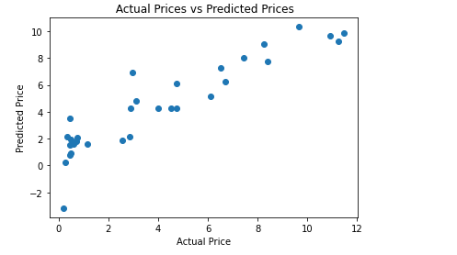

1. **Lasso Regression Model:**

**Acuuracy:** 0.8709167941173195

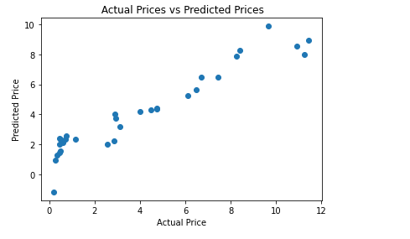

Above we use two models but accuracy of lasso regression model is highest. Now, I will deploy my model.